まとめ

Expasyの比較

Ck-CH1-Hinge-Ch2-CH3

|  |  |  |  |  |  |
| --- | --- | --- | --- | --- | --- |
| Class Subclass | MW | pI | Instability index | Aliphatic index | GRAVY |
| Mouse Ck-IgG1 | 47500.41 | 6.03 | ­39.93 | 64.51 | -0.440 |
| Mouse Ck-IgG2a | 48278.44 | 6.29 | 46.32 | 69.02 | -0.439 |
| Mouse Ck-IgG2b | 48399.45 | 6.40 | 47.72 | 70.68 | -0.403 |
| Mouse Ck-IgG3 | 48188.33 | 7.24 | 45.14 | 70.39 | -0.426 |
| Rabbit Cka-IgG | 46528.55 | 7.92 | 40.85 | 69.04 | -0.360 |
| Rabbit Ckb-IgG | 46551.52 | 7.13 | 48.66 | 70.02 | -0.361 |

CH1-Hinge-CH2-CH3

|  |  |  |  |  |  |
| --- | --- | --- | --- | --- | --- |
| Class Subclass | MW | pI | Instability index | Aliphatic index | GRAVY |
| Mouse IgG1 | 35740.55 | 6.33 | 36.84 | 67.87 | -0.348 |
| Mouse IgG2a | 36518.57 | 6.82 | 45.34 | 73.75 | -0.348 |
| Mouse IgG2b | 36639.58 | 7.19 | 47.19 | 75.86 | -0.302 |
| Mouse IgG3 | 36428.46 | 8.36 | 43.78 | 75.56 | -0.332 |
| Rabbit IgG | 35347.19 | 8.62 | 47.58 | 70.19 | -0.379 |
|  |  |  |  |  |  |

Ck

|  |  |  |  |  |  |
| --- | --- | --- | --- | --- | --- |
| Class Subclass | MW | pI | Instability index | Aliphatic index | GRAVY |
| Mouse Ck | 11777.88 | 5.23 | 49.30 | 54.25 | -0.722 |
| Rabbit Ck1 | 11199.38 | 4.75 | 19.83 | 65.48 | -0.299 |
| Rabbit Ck2 | 11222.35 | 4.45 | 51.86 | 69.52 | -0.304 |
|  |  |  |  |  |  |

Fc (Hinge-CH2-CH3)

|  |  |  |  |  |  |
| --- | --- | --- | --- | --- | --- |
| Class Subclass | MW | pI | Instability index | Aliphatic index | GRAVY |
| Mouse IgG1 | 25589.04 | 5.99 | 34.10 | 63.72 | -0.534 |
| Mouse IgG2a | 26257.04 | 7.36 | 40.86 | 72.07 | -0.515 |
| Mouse IgG2b | 26603.28 | 6.70 | 45.84 | 78.07 | -0.456 |
| Mouse IgG3 | 26192.79 | 7.86 | 37.20 | 70.60 | -0.561 |
| Rabbit IgG | 25597.12 | 8.22 | 49.90 | 67.89 | -0.550 |
|  |  |  |  |  |  |

CH1

|  |  |  |  |  |  |
| --- | --- | --- | --- | --- | --- |
| Class Subclass | MW | pI | Instability index | Aliphatic index | GRAVY |
| Mouse IgG1 | 10169.52 | 8.04 | 41.08 | 77.45 | 0.080 |
| Mouse IgG2a | 10150.43 | 6.93 | 50.91 | 78.47 | 0.080 |
| Mouse IgG2b | 10056.29 | 6.93 | 48.39 | 69.49 | 0.056 |
| Mouse IgG3 | 10253.69 | 8.57 | 56.00 | 87.35 | 0.213 |
| Rabbit IgG | 9768.08 | 8.85 | 41.93 | 75.68 | 0.029 |
|  |  |  |  |  |  |

CH2

|  |  |  |  |  |  |
| --- | --- | --- | --- | --- | --- |
| Class Subclass | MW | pI | Instability index | Aliphatic index | GRAVY |
| Mouse IgG1 | 12205.93 | 5.31 | 39.67 | 77.41 | -0.279 |
| Mouse IgG2a | 12367.20 | 5.86 | 38.26 | 92.88 | -0.196 |
| Mouse IgG2b | 12458.23 | 5.87 | 38.66 | 88.47 | -0.305 |
| Mouse IgG3 | 12423.32 | 8.75 | 30.39 | 78.02 | -0.368 |
| Rabbit IgG | 12422.36 | 9.11 | 44.27 | 83.94 | -0.420 |
|  |  |  |  |  |  |

CH3

|  |  |  |  |  |  |
| --- | --- | --- | --- | --- | --- |
| Class Subclass | MW | pI | Instability index | Aliphatic index | GRAVY |
| Mouse IgG1 | 12123.57 | 6.20 | 30.12 | 53.30 | -0.838 |
| Mouse IgG2a | 12331.89 | 6.40 | 45.03 | 56.79 | -0.818 |
| Mouse IgG2b | 11970.50 | 7.93 | 43.52 | 76.23 | -0.585 |
| Mouse IgG3 | 12155.62 | 6.07 | 36.05 | 69.81 | -0.677 |
| Rabbit IgG | 12022.41 | 5.88 | 52.51 | 58.22 | -0.682 |
|  |  |  |  |  |  |

まとめ

アミノ酸組成の比較

Ck-CH1-Hinge-CH2-CH3

|  |  |  |  |  |  |  |  |  |  |
| --- | --- | --- | --- | --- | --- | --- | --- | --- | --- |
| Class Subclass | C | K | K+R | D+E | G | P | S+T | I+L+V | F+W+Y |
| Mouse Ck-IgG1 | 13 | 31 | 39  31+8 | 45  22+23 | 17 | 36 | 92  49+43 | 76  16+21+39 | 38  18+9+11 |
| Mouse Ck-IgG2a | 13 | 31 | 42  31+11 | 46  22+24 | 19 | 36 | 93  51+42 | 84  16+26+42 | 35  13+8+14 |
| Mouse Ck-IgG2b | 14 | 31 | 42  31+11 | 45  24+21 | 22 | 36 | 99  58+41 | 86  20+27+39 | 35  13+8+14 |
| Mouse Ck-IgG3 | 11 | 29 | 43  29+14 | 43  20+23 | 21 | 38 | 92  53+39 | 84  18+27+39 | 37  15+9+13 |
| Rabbit Cka-IgG | 14 | 24 | 39  24+15 | 37  18+19 | 22 | 40 | 95  45+50 | 82  13+25+44 | 32  13+6+13 |
| Rabbit Ckb-IgG | 13 | 24 | 38  24+14 | 38  17+21 | 22 | 42 | 96  53+43 | 83  14+27+42 | 32  13+6+13 |

CH1-Hinge-CH2-CH3

|  |  |  |  |  |  |  |  |  |  |
| --- | --- | --- | --- | --- | --- | --- | --- | --- | --- |
| Class Subclass | C | K | K+R | D+E | G | P | S+T | I+L+V | F+W+Y |
| Mouse IgG1 | 10 | 24 | 29  24+5 | 32  15+17 | 13 | 31 | 65  33+32 | 61  12+16+33 | 28  14+7+7 |
| Mouse IgG2a | 10 | 24 | 32  24+8 | 33  15+18 | 15 | 31 | 66  35+31 | 69  12+21+36 | 25  9+6+10 |
| Mouse IgG2b | 11 | 24 | 32  24+8 | 32  17+15 | 18 | 31 | 72  42+30 | 71  16+22+33 | 25  9+6+10 |
| Mouse IgG3 | 8 | 22 | 33  22+11 | 30  13+17 | 17 | 33 | 65  37+28 | 69  14+22+33 | 27  11+7+9 |
| Rabbit IgG | 10 | 20 | 33  20+13 | 28  12+16 | 17 | 34 | 67  37+30 | 63  10+21+32 | 24  10+5+9 |
|  |  |  |  |  |  |  |  |  |  |

Ck

|  |  |  |  |  |  |  |  |  |  |
| --- | --- | --- | --- | --- | --- | --- | --- | --- | --- |
| Class Subclass | C | K | K+R | D+E | G | P | S+T | I+L+V | F+W+Y |
| Mouse Ck | 3 | 7 | 10  7+3 | 13  7+6 | 4 | 5 | 27  16+11 | 15  4+5+6 | 10  4+2+4 |
| Rabbit Ck1 | 4 | 4 | 6  4+2 | 9  6+3 | 5 | 6 | 28  8+20 | 19  3+4+12 | 8  3+1+4 |
| Rabbit Ck2 | 3 | 4 | 5  4+1 | 10  5+5 | 5 | 8 | 29  16+13 | 20  4+6+10 | 8  3+1+4 |

Fc (Hinge-CH2-CH3)

|  |  |  |  |  |  |  |  |  |  |
| --- | --- | --- | --- | --- | --- | --- | --- | --- | --- |
| Class Subclass | C | K | K+R | D+E | G | P | S+T | I+L+V | F+W+Y |
| Mouse IgG1 | 8 | 19 | 24  19+5 | 28  13+15 | 8 | 21 | 36  17+19 | 40  11+9+20 | 21  12+5+4 |
| Mouse IgG2a | 7 | 19 | 27  19+8 | 27  12+15 | 9 | 23 | 35  18+17 | 48  10+13+25 | 18  7+4+7 |
| Mouse IgG2b | 8 | 20 | 27  20+7 | 28  15+13 | 11 | 22 | 39  23+16 | 52  16+14+22 | 18  7+4+7 |
| Mouse IgG3 | 5 | 18 | 27  18+7 | 26  12+14 | 10 | 25 | 37  20+17 | 45  11+14+20 | 19  9+5+5 |
| Rabbit IgG | 6 | 16 | 27  16+11 | 25  10+15 | 10 | 24 | 40  23+17 | 42  10+14+18 | 19  8+4+7 |
|  |  |  |  |  |  |  |  |  |  |

VH/VL（rabbit scFv ６７０クローンの平均） VH 115 aa, VL 110 aa

|  |  |  |  |  |  |  |  |  |  |
| --- | --- | --- | --- | --- | --- | --- | --- | --- | --- |
| Class Subclass | C | K | K+R | D+E | G | P | S+T | I+L+V | F+W+Y |
| Rabbit VH | 2 | 4 | 8  4+4 | 7  2+5 | 15 | 5 | 32  16+16 | 18  4+9+5 | 15  4+5+6 |
| Rabbit VL | 4 | 3 | 5  4+1 | 7  4+3 | 14 | 4 | 26  13+13 | 24  6+10+8 | 11  3+1+7 |

CH1

|  |  |  |  |  |  |  |  |  |  |
| --- | --- | --- | --- | --- | --- | --- | --- | --- | --- |
| Class Subclass | C | K | K+R | D+E | G | P | S+T | I+L+V | F+W+Y |
| Mouse IgG1 | 2 | 5 | 5  5+0 | 4  2+2 | 5 | 10 | 29  16+13 | 21  1+7+13 | 7  2+2+3 |
| Mouse IgG2a | 3 | 5 | 5  5+0 | 5  3+2 | 6 | 8 | 31  17+14 | 21  2+8+11 | 7  2+2+3 |
| Mouse IgG2b | 3 | 4 | 4  4+0 | 4  2+2 | 7 | 9 | 34  19+15 | 19  0+8+11 | 7  2+2+3 |
| Mouse IgG3 | 3 | 4 | 5  3+2 | 4  1+3 | 7 | 8 | 28  17+11 | 24  3+8+13 | 8  2+2+4 |
| Rabbit IgG | 4 | 4 | 6  4+2 | 3  2+1 | 7 | 10 | 27  14+13 | 21  0+7+14 | 5  2+1+2 |

Hinge

|  |  |  |  |  |  |  |  |  |  |  |
| --- | --- | --- | --- | --- | --- | --- | --- | --- | --- | --- |
| Class Subclass | Length | C | K | K+R | D+E | G | P | S+T | I+L+V | F+W+Y |
| Mouse IgG1 | 12 | 4 | 1 | 2  1+1 | 1  1+0 | 1 | 2 | 1  0+1 | 1  1+0+0 | 0  0+0+0 |
| Mouse IgG2a | 15 | 3 | 2 | 3  2+1 | 0  0+0 | 1 | 6 | 1  0+1 | 1  1+0+0 | 0  0+0+0 |
| Mouse IgG2b | 21 | 4 | 2 | 2  2+0 | 1  0+1 | 1 | 6 | 3  2+1 | 2  2+0+0 | 0  0+0+0 |
| Mouse IgG3 | 15 | 1 | 1 | 2  1+1 | 0  0+0 | 1 | 6 | 4  3+1 | 1  1+0+0 | 0  0+0+0 |
| Rabbit IgG | 12 | 2 | 1 | 1  1+0 | 0  0+0 | 0 | 4 | 4  2+2 | 0  0+0+0 | 0  0+0+0 |
|  |  |  |  |  |  |  |  |  |  |  |

CH2

|  |  |  |  |  |  |  |  |  |  |
| --- | --- | --- | --- | --- | --- | --- | --- | --- | --- |
| Class Subclass | C | K | K+R | D+E | G | P | S+T | I+L+V | F+W+Y |
| Mouse IgG1 | 2 | 9 | 12  9+3 | 15  7+8 | 2 | 10 | 18  9+9 | 24  6+4+14 | 10  8+2+0 |
| Mouse IgG2a | 2 | 8 | 11  8+3 | 13  8+5 | 4 | 10 | 15  9+6 | 29  8+7+14 | 7  4+2+1 |
| Mouse IgG2b | 2 | 8 | 12  8+4 | 14  8+6 | 4 | 9 | 16  9+7 | 28  9+5+14 | 7  4+2+1 |
| Mouse IgG3 | 2 | 10 | 14  10+4 | 12  7+5 | 5 | 12 | 13  7+6 | 24  6+5+13 | 9  5+3+1 |
| Rabbit IgG | 2 | 8 | 15  8+7 | 12  5+7 | 3 | 12 | 14  6+8 | 25  7+7+11 | 8  5+2+1 |

CH3

|  |  |  |  |  |  |  |  |  |  |
| --- | --- | --- | --- | --- | --- | --- | --- | --- | --- |
| Class Subclass | C | K | K+R | D+E | G | P | S+T | I+L+V | F+W+Y |
| Mouse IgG1 | 2 | 9 | 10  9+1 | 12  5+7 | 5 | 9 | 17  8+9 | 15  4+5+6 | 11  4+3+4 |
| Mouse IgG2a | 2 | 9 | 13  9+4 | 14  4+10 | 4 | 7 | 19  9+10 | 18  1+6+11 | 11  3+2+6 |
| Mouse IgG2b | 2 | 10 | 14  10+4 | 13  7+6 | 6 | 7 | 19  12+7 | 22  5+9+8 | 11  3+2+6 |
| Mouse IgG3 | 2 | 7 | 11  7+4 | 13  5+8 | 4 | 7 | 20  10+10 | 20  4+9+7 | 12  4+2+4 |
| Rabbit IgG | 2 | 7 | 11  7+4 | 13  5+8 | 7 | 8 | 22  15+7 | 17  3+7+7 | 11  3+2+6 |

Hopp & Woods Hydrophobicity

Mouse IgG1

CH1

Mouse IgG1 CH2

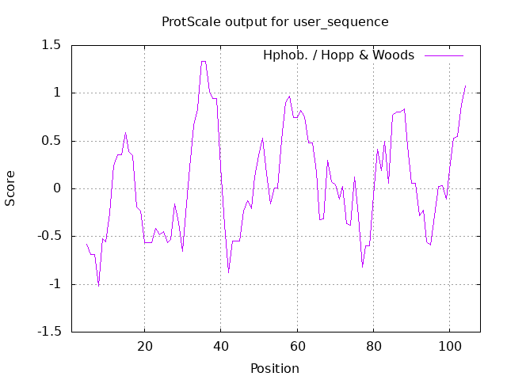

Mouse IgG1 CH3

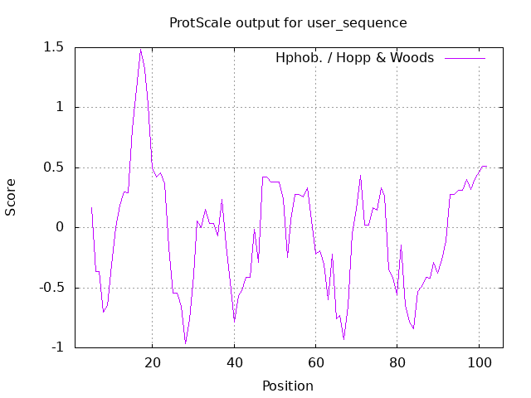

Mouse IgG1 CH1-Hinge-CH2-CH3

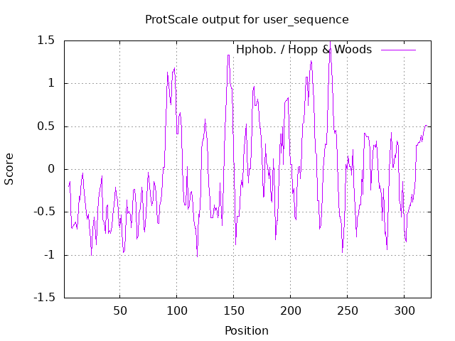

Mouse IgG2a

CH1

Mouse IgG2a CH2

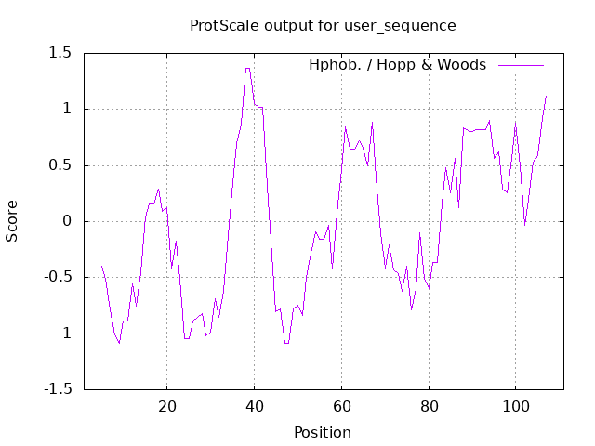

Mouse IgG2a CH3

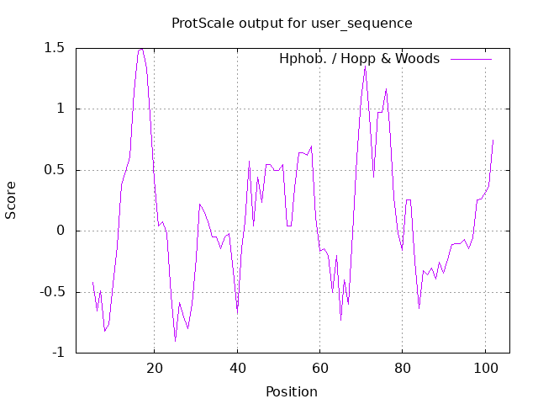

Mouse IgG2a CH1-Hinge-CH2-CH3

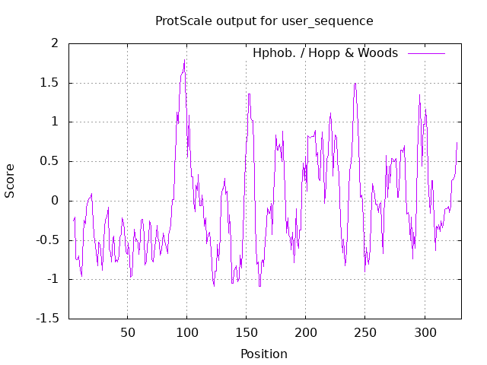

Mouse IgG2b

CH1

Mouse IgG2b CH2

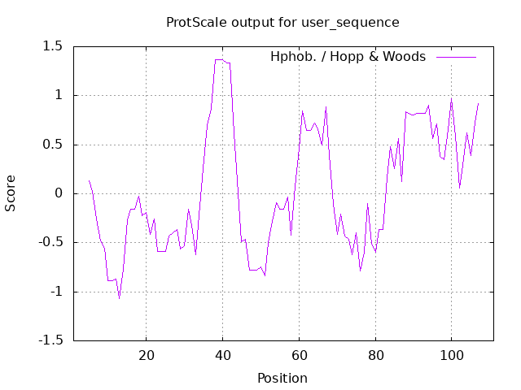

Mouse IgG2b CH3

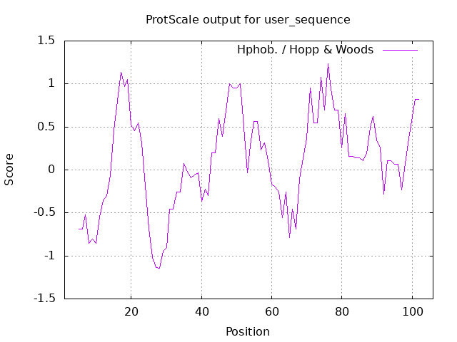

Mouse IgG2b CH1-Hinge-CH2-CH3

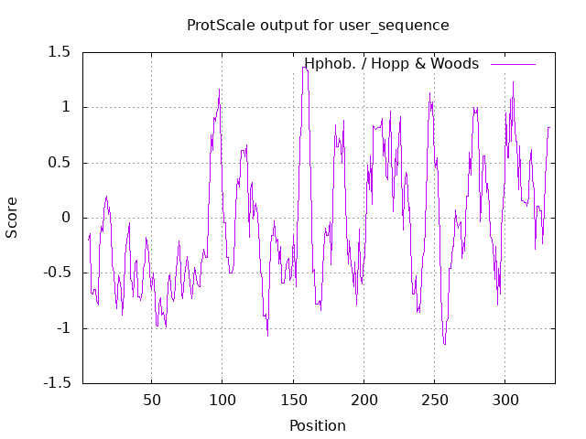

Mouse IgG3

CH1

Mouse IgG3 CH2

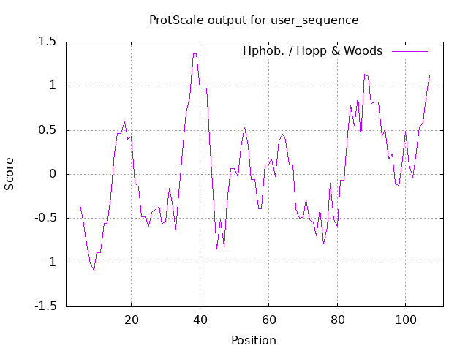

Mouse IgG3 CH3

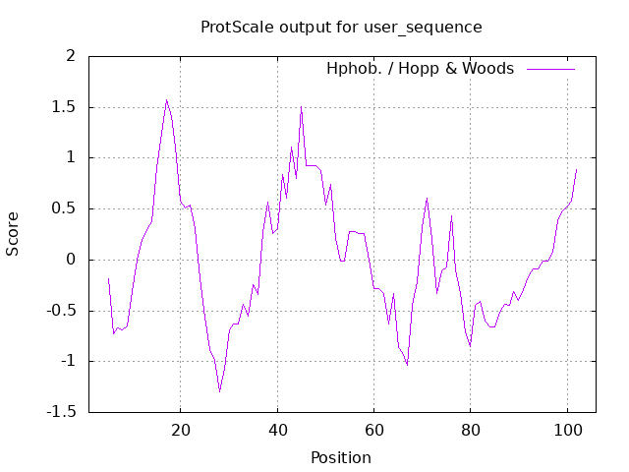

Mouse IgG3 CH1-Hinge-CH2-CH3

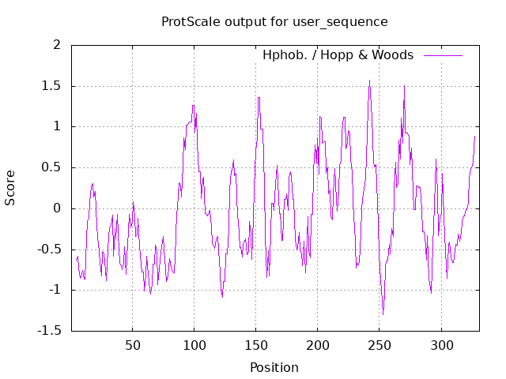

Rabbit IgG

CH1

Rabbit IgG CH2

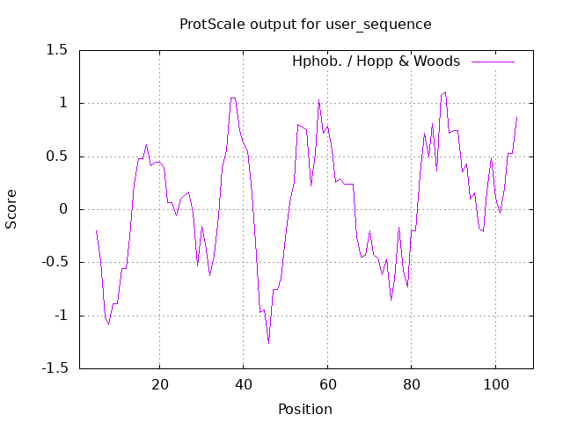

Rabbit IgG CH3

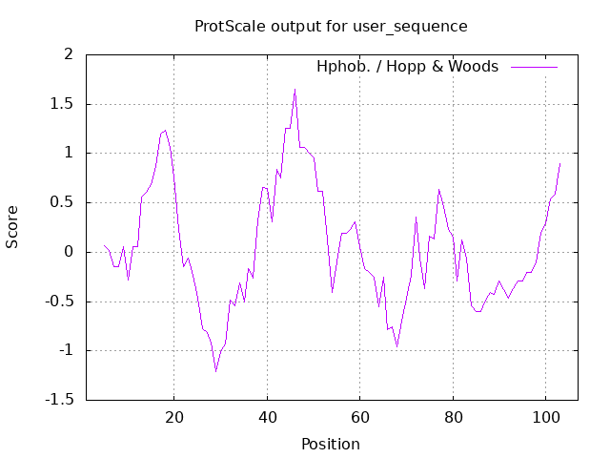

Rabbit IgG CH1-Hinge-CH2-CH3

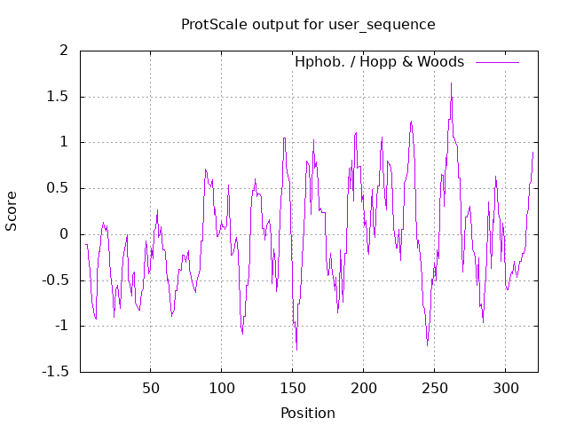

Mouse Ck

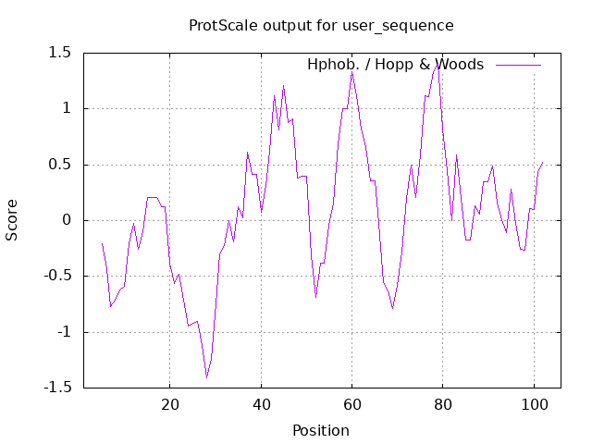

Rabbit Ck1

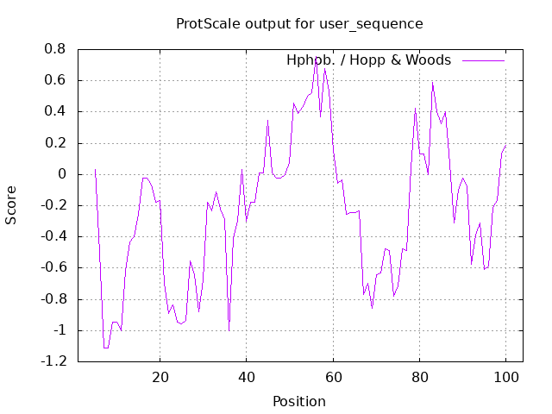

Rabbit Ck2

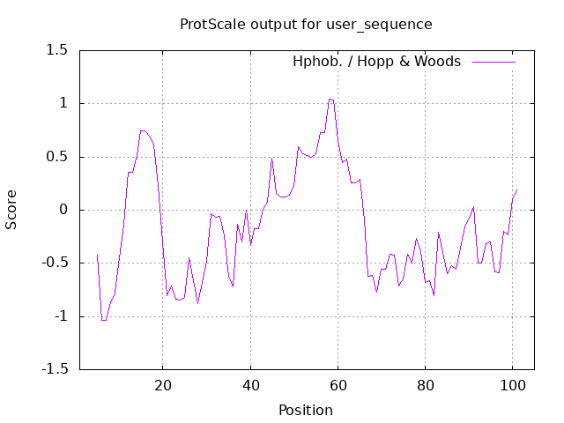

CH1-Hinge-CH2-CH3

Mouse IgG1 Mouse IgG2a



Mouse IgG2b Mouse IgG3



Rabbit IgG

